Volatility Modelling
Historical, EWMA, GARCH & Implied Volatility
Estimating and Forecasting How Much a Return Series Moves — and How That Itself Changes Through Time
A Level 2 module in the Quantitative Finance Curriculum — revisited at Level 5
Covers: Historical / realised / rolling volatility · EWMA · volatility clustering · ARCH / GARCH / EGARCH / GJR-GARCH · implied volatility · volatility surface / smile / skew / term structure (awareness)

Table of Contents
How to Use This Guide
What You Need to Know Before Starting
Why It Matters
How This Connects to the Rest of the Curriculum
Glossary of Recurring Terms
Part 1 — Measuring Volatility: Historical, Realised, and Rolling Estimators
1.1 Historical / Realised Volatility
1.2 Rolling Volatility Windows
1.3 The Exponentially Weighted Moving Average (EWMA)
1.4 Volatility Clustering
Part 2 — Modelling Time-Varying Volatility: ARCH and GARCH
2.1 ARCH: The First Conditional Volatility Model
2.2 GARCH(1,1): Adding Persistence
2.3 Asymmetric Volatility: EGARCH and GJR-GARCH
2.4 Fitting and Forecasting with GARCH
Part 3 — Implied Volatility and the Volatility Surface (Awareness Level)
3.1 Implied Volatility: Inverting the Pricing Formula
3.2 The Volatility Smile and Skew
3.3 The Volatility Term Structure
3.4 The Volatility Surface as a Whole
Practical Exercise
Common Beginner Mistakes
Advanced Extensions
Professional Applications
Where to Go Next

How to Use This Guide
This document is a companion to Volatility Modelling, the second-level module in the quantitative finance curriculum that is revisited in far greater depth at Level 5. It covers methods for estimating and forecasting how much a return series moves, and — the harder and more interesting question — how that amount of movement itself changes through time.
The module is self-contained: every concept is introduced from first principles, paired with a short runnable Python sketch, and illustrated with a chart wherever a picture makes the idea land faster than an equation. Read it start to finish if volatility modelling is new to you, or jump straight to the section you need.

What You Need to Know Before Starting
- Time Series — stationarity, the ACF/PACF, and the AR/MA/ARMA vocabulary, since GARCH models (Part 2) are structurally an ARMA model applied to squared returns rather than to returns themselves.
- Statistics — variance, standard deviation, and basic distributional concepts, which this module uses constantly and does not re-derive.

Why It Matters
Volatility is the single most important input to risk management, position sizing, and derivatives pricing. Value-at-Risk limits, portfolio construction's volatility-targeting rules, and every option pricing formula all take a volatility estimate as a direct input — and unlike a stock's expected return, which is notoriously hard to estimate with any precision, volatility is comparatively forecastable, which is exactly why so much modelling effort is spent on it.

How This Connects to the Rest of the Curriculum
- Research — volatility forecasts feed position sizing (volatility targeting) and risk-scaled signal construction, where a signal's size is deliberately scaled inversely to current or forecast volatility.
- Development — rolling and EWMA volatility calculations are core, high-frequency-use utility functions, called constantly throughout a research and production codebase rather than being a one-off analysis.
- Trading — implied volatility and the volatility surface are the primary language of options desks, who think and quote in volatility terms as naturally as other desks think in price terms.

Glossary of Recurring Terms
Historical / realised volatility — The standard deviation of a return series computed directly from observed past returns over some fixed lookback period.
Rolling volatility — A historical volatility estimate recomputed at every time step using only the most recent fixed-length window of returns, so the estimate updates as time moves forward.
EWMA (exponentially weighted moving average) — A volatility estimator that weights all past squared returns, but with exponentially decaying weight on older observations, controlled by a single decay parameter λ.
Volatility clustering — The empirical tendency for large returns (of either sign) to be followed by more large returns, and small returns to be followed by more small returns — i.e., volatility is itself serially correlated.
ARCH (Autoregressive Conditional Heteroskedasticity) — A model in which current conditional variance is a function of past squared return shocks.
GARCH (Generalised ARCH) — An extension of ARCH that also includes past conditional variance itself as a predictor of current conditional variance, allowing volatility shocks to persist far longer with far fewer parameters than plain ARCH.
EGARCH / GJR-GARCH — Asymmetric extensions of GARCH that allow negative return shocks to raise future volatility by more than equally sized positive shocks — the empirical 'leverage effect.'
Implied volatility — The volatility value that, when input into an option pricing model (typically Black-Scholes), reproduces an option's observed market price — a forward-looking, market-priced estimate rather than a backward-looking, computed one.
Volatility smile / skew — The empirical pattern in which implied volatility varies systematically across strike prices for options of the same maturity, rather than being constant as simple option pricing theory would suggest.
Volatility term structure — The pattern of implied volatility across different maturities for options of the same (or similar) moneyness.
Volatility surface — The full two-dimensional grid of implied volatility across both strike and maturity simultaneously, combining the smile/skew and the term structure into a single object.

Part 1 — Measuring Volatility: Historical, Realised, and Rolling Estimators
This part covers the simplest ways to answer 'how volatile has this series been' — historical, rolling, and exponentially weighted estimators — and introduces the single empirical fact, volatility clustering, that motivates every model in Part 2.

1.1 Historical / Realised Volatility
The most direct volatility estimate is simply the sample standard deviation of a return series over some lookback window:
σ̂ = √[ (1/(n−1)) Σᵢ (rᵢ − r̄)² ]
In finance this is almost always annualised for comparability across assets and horizons, by scaling the daily (or other-frequency) standard deviation by the square root of the number of periods per year — √252 for daily data, assuming roughly 252 trading days:
σ̂ₐₙₙᵤₐₗ = σ̂ₐₐᵢₗᵧ × √252
import numpy as np

daily_vol = returns.std()
annualised_vol = daily_vol * np.sqrt(252)
Tip — The square-root-of-time scaling assumes returns are independent and identically distributed across periods — an assumption Part 1's own Section 1.4 is about to undermine. It remains a useful rule of thumb and industry convention, but it systematically understates risk over longer horizons whenever volatility clusters, since a bad period doesn't 'average out' as fast as √t scaling assumes.

1.2 Rolling Volatility Windows
A single historical volatility number describes the past; a rolling estimate turns it into a time series, recomputing the same calculation at every point in time using only the most recent w observations:
σ̂ₜ = √[ (1/(w−1)) Σᵢ₌ₜ₋w₊₁ᵗ (rᵢ − r̄ₜ)² ]
The window length w is a direct bias-variance trade-off: a short window (e.g. 20 days) reacts quickly to genuine changes in volatility but is noisy, since it is estimated from few observations; a long window (e.g. 60 or 120 days) is smoother and more stable but reacts sluggishly, continuing to reflect a volatility spike long after it has actually passed, purely because that spike is still sitting inside the window.
rolling_vol_20 = returns.rolling(window=20).std()
rolling_vol_60 = returns.rolling(window=60).std()

1.3 The Exponentially Weighted Moving Average (EWMA)
EWMA addresses the rolling-window trade-off differently: instead of a hard cutoff at w days, every past observation is used, but with weight decaying exponentially the further back it sits, controlled by a single decay parameter λ:
σ̂ₜ² = λ σ̂ₜ₋₁² + (1 − λ) rₜ₋₁²
A higher λ (closer to 1) puts more weight on the past and produces a smoother, slower-reacting estimate, much like a long rolling window; a lower λ reacts faster, like a short window. The widely used RiskMetrics convention sets λ = 0.94 for daily data, a level chosen empirically to balance responsiveness against noise across a broad range of assets:
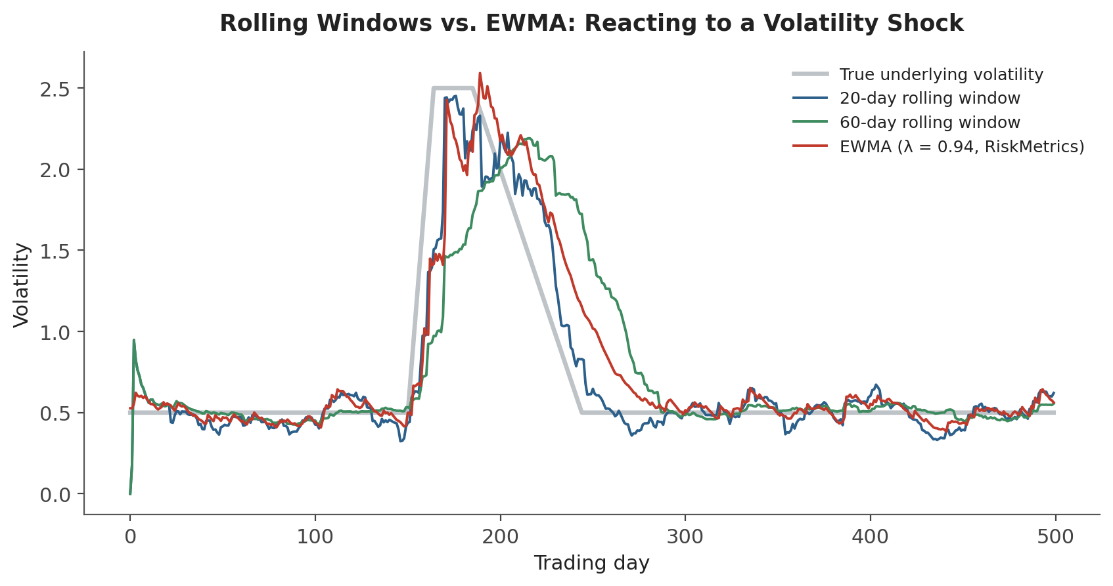
Figure 1.1 — Reacting to a sudden volatility shock and its decay. The 20-day rolling window reacts fastest but is noisiest; the 60-day window is smoothest but lags noticeably on both the way up and the way down; EWMA (λ = 0.94) sits between the two, reacting almost as fast as the short window while remaining considerably smoother.
def ewma_vol(returns, lam=0.94):
var = np.zeros(len(returns))
var[0] = returns.iloc[0] ** 2
for t in range(1, len(returns)):
var[t] = lam * var[t-1] + (1 - lam) * returns.iloc[t-1] ** 2
return np.sqrt(var)
EWMA as a special case — EWMA is mathematically a restricted version of the GARCH(1,1) model covered in Section 2.2, with the long-run variance term (ω) fixed at zero and α + β constrained to exactly 1. GARCH generalises EWMA by estimating all of these parameters from the data rather than fixing them by convention.

1.4 Volatility Clustering
Across virtually every liquid financial return series ever studied, one empirical pattern shows up reliably: large moves (of either sign) tend to be followed by more large moves, and calm periods by more calm periods. This is volatility clustering, and it is the single stylised fact that every model in Part 2 exists to capture.
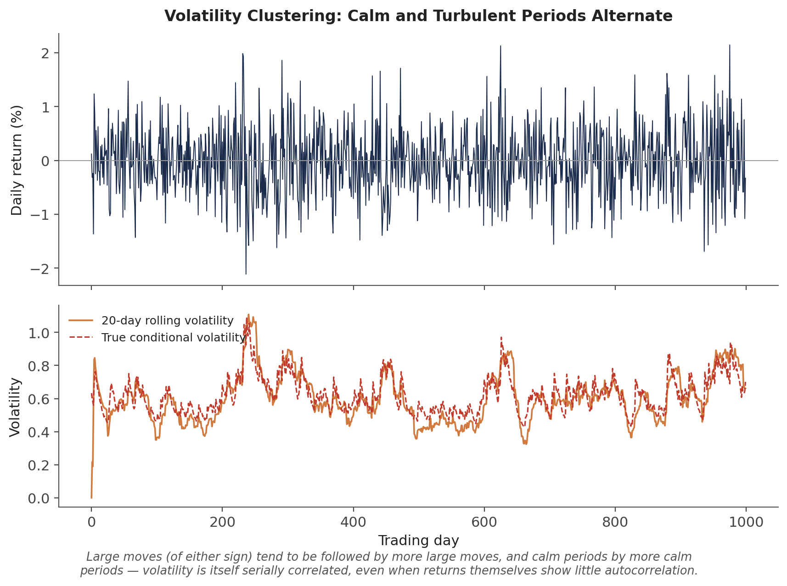
Figure 1.2 — The turbulent and calm periods in the return series (top) are not randomly scattered — they cluster, producing the clearly non-constant rolling volatility path (bottom). Returns themselves typically show little to no autocorrelation, but their magnitude (or squared value) is strongly autocorrelated.
Common mistake — Using a single unconditional (constant) volatility estimate for risk management despite well-documented volatility clustering. A single number computed once from a long historical sample will be too high during calm periods (over-hedging, oversized risk budgets left unused) and too low exactly when it matters most — heading into or during a turbulent period, which is precisely when an underestimate is most costly.

Part 2 — Modelling Time-Varying Volatility: ARCH and GARCH
This part introduces the class of models built specifically to capture volatility clustering: models where the variance of today's return is explicitly allowed to depend on the recent past, rather than being treated as a fixed constant.

2.1 ARCH: The First Conditional Volatility Model
ARCH(q), introduced by Robert Engle (for which he later won the Nobel Prize in Economics), models the conditional variance of today's return as a function of the past q squared return shocks:
rₜ = σₜ zₜ, zₜ ~ i.i.d.(0,1)
σₜ² = ω + α₁rₜ₋₁² + α₂rₜ₋₂² + … + α_qrₜ₋q²
The intuition is direct: a large squared return shock yesterday (rₜ₋₁²) directly raises today's forecast variance, which is exactly the clustering behaviour observed in Figure 1.2. The practical limitation is that capturing realistic, long-lived volatility persistence with plain ARCH typically requires a large number of lags q, each with its own parameter to estimate — an unwieldy model that GARCH was introduced specifically to fix.

2.2 GARCH(1,1): Adding Persistence
GARCH(p, q), introduced by Tim Bollerslev, adds lagged conditional variance itself as an additional predictor. The GARCH(1,1) specification — by far the most widely used volatility model in practice — needs just three parameters to capture what ARCH would need many lags to approximate:
σₜ² = ω + α rₜ₋₁² + β σₜ₋₁²
Here ω is a constant (related to the long-run average variance), α measures how strongly the most recent squared shock moves today's variance, and β measures how much of yesterday's conditional variance carries over. The sum α + β measures persistence: how slowly a volatility shock decays back toward its long-run average. Values of α + β close to 1 (commonly observed in real financial data, often in the 0.95–0.99 range) indicate that shocks to volatility die out very slowly — a spike in volatility today should be expected to still be partly present weeks or months later.
Long-run variance: σ̄² = ω / (1 − α − β) (requires α + β < 1 for stationarity)
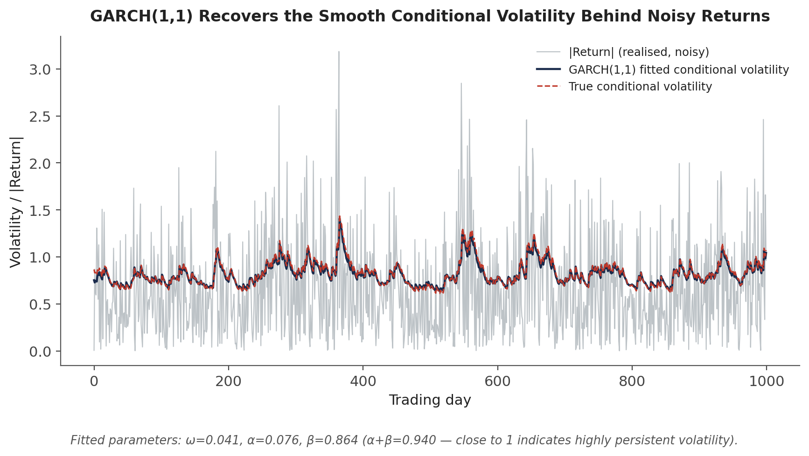
Figure 2.1 — Squared (or absolute) returns are an extremely noisy, unbiased estimate of the true underlying variance at each point in time. GARCH(1,1) filters through that noise to recover a smooth estimate that tracks the true conditional volatility closely — here recovering the underlying process almost exactly, since the simulated data was itself generated by a GARCH(1,1) process.
from arch import arch_model

am = arch_model(returns * 100, vol='GARCH', p=1, q=1, dist='normal')
res = am.fit(disp='off')
print(res.params) # omega, alpha[1], beta[1]
print(res.conditional_volatility) # in-sample fitted volatility path
Tip — The arch package (and most GARCH implementations) work best when returns are scaled to a moderate numerical range — multiplying returns by 100 to work in percentage points, as above, is standard practice and avoids numerical optimisation problems that can occur with raw decimal returns.

2.3 Asymmetric Volatility: EGARCH and GJR-GARCH
Plain GARCH treats a positive and a negative shock of the same size identically, since only the squared shock rₜ₋₁² enters the model. Empirically, this is wrong for most equity markets: a large negative return tends to raise future volatility by more than an equally sized positive return — the leverage effect, originally attributed to a falling stock price mechanically raising a firm's leverage ratio, though the effect is now understood to also reflect volatility feedback and risk-premium dynamics more broadly.
GJR-GARCH (Glosten-Jagannathan-Runkle) adds a single extra term that activates only for negative shocks:
σₜ² = ω + α rₜ₋₁² + γ rₜ₋₁² 𝟙(rₜ₋₁ < 0) + β σₜ₋₁²
EGARCH (Exponential GARCH, Nelson 1991) instead models the log of the conditional variance directly, which has the added benefit of guaranteeing variance stays positive without needing to constrain any parameters to be non-negative:
ln(σₜ²) = ω + β ln(σₜ₋₁²) + θ zₜ₋₁ + γ [ |zₜ₋₁| − E|zₜ₋₁| ]
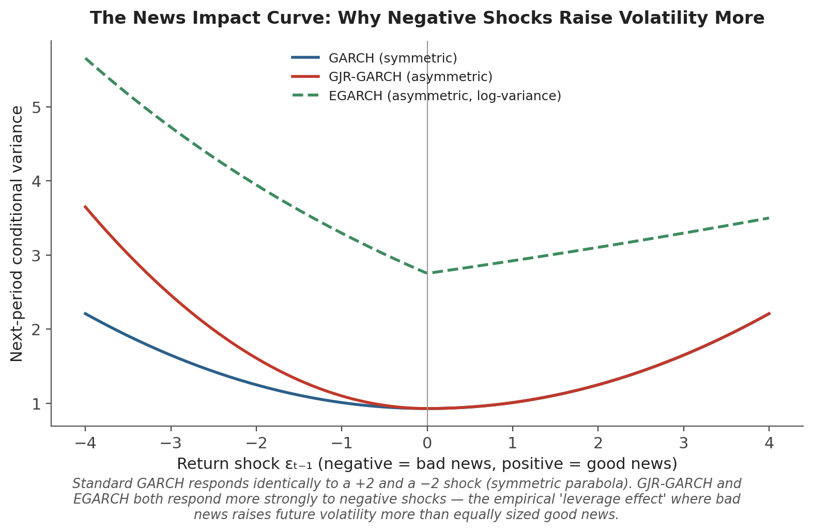
Figure 2.2 — The 'news impact curve' plots next-period conditional variance against the size and sign of the latest return shock. Standard GARCH is a symmetric parabola; GJR-GARCH and EGARCH are both steeper on the negative side, quantifying the leverage effect directly.
from arch import arch_model

am_gjr = arch_model(returns * 100, vol='GARCH', p=1, o=1, q=1, dist='normal') # o=1 adds the GJR term
res_gjr = am_gjr.fit(disp='off')

am_egarch = arch_model(returns * 100, vol='EGARCH', p=1, o=1, q=1, dist='normal')
res_egarch = am_egarch.fit(disp='off')

2.4 Fitting and Forecasting with GARCH
GARCH parameters are estimated by maximum likelihood, choosing ω, α, β (and any asymmetry terms) to maximise the probability of the observed return series under the model's assumed conditional distribution — normal, or more commonly in practice a fat-tailed distribution such as Student's t, since even after accounting for time-varying volatility, financial returns typically retain fatter tails than a normal distribution predicts.
Once fitted, a GARCH model produces a forecast by iterating its own variance equation forward: the h-step-ahead forecast for GARCH(1,1) is
E[σₜ₊ₕ² | information at t] = σ̄² + (α + β)ʰ⁻¹ (σₜ₊₁² − σ̄²)
which decays geometrically from the current forecast toward the long-run variance σ̄² at a rate governed by α + β — precisely the persistence measure introduced in Section 2.2.
forecast = res.forecast(horizon=10)
forecast_vol = np.sqrt(forecast.variance.values[-1]) # 10-day-ahead variance path

Part 3 — Implied Volatility and the Volatility Surface (Awareness Level)
Everything in Parts 1 and 2 is backward-looking: computed from a history of realised returns. This part covers a fundamentally different, forward-looking source of volatility information — the volatility the options market itself is pricing in — at the awareness level appropriate for a Level 2 module, since full option pricing theory and volatility surface modelling are covered in depth much later in the curriculum.

3.1 Implied Volatility: Inverting the Pricing Formula
The Black-Scholes option pricing formula takes volatility as one of its inputs and produces a theoretical option price as output. Implied volatility inverts this relationship: given an option's actual observed market price, implied volatility is whatever value of σ, plugged back into Black-Scholes, reproduces that observed price exactly:
Given: C_market = observed call price
Solve for σ_implied such that: C_BlackScholes(S, K, T, r, σ_implied) = C_market
Because Black-Scholes has no closed-form inverse for σ, implied volatility is found numerically (bisection or Newton-Raphson) rather than algebraically. The result is a market-implied, forward-looking volatility estimate that reflects the market's collective expectation of future volatility over the option's remaining life — as distinct from historical volatility, which only describes the past.
Common mistake — Confusing historical (realised) volatility with implied (forward-looking, market-priced) volatility. These are two different objects estimated from two entirely different sources of data — one from a time series of past returns, the other from current option prices — and they routinely disagree, sometimes substantially. Implied volatility also embeds a volatility risk premium (options tend to be priced for somewhat more volatility than subsequently realises, on average), so the two are not even expected to match exactly.
from scipy.optimize import brentq
from scipy.stats import norm
import numpy as np

def bs_call_price(S, K, T, r, sigma):
d1 = (np.log(S/K) + (r + 0.5*sigma**2)*T) / (sigma*np.sqrt(T))
d2 = d1 - sigma*np.sqrt(T)
return S*norm.cdf(d1) - K*np.exp(-r*T)*norm.cdf(d2)

implied_vol = brentq(
lambda sigma: bs_call_price(S, K, T, r, sigma) - market_price,
1e-4, 5.0,
)

3.2 The Volatility Smile and Skew
If Black-Scholes' constant-volatility assumption held exactly, every option on the same underlying and maturity — regardless of strike — would imply the same volatility. In practice it does not: implied volatility varies systematically with strike, a pattern called the volatility smile (roughly symmetric, higher at both extremes — typical in FX markets) or volatility skew (asymmetric, typically higher for downside strikes — the dominant pattern in equity index markets since the 1987 crash):
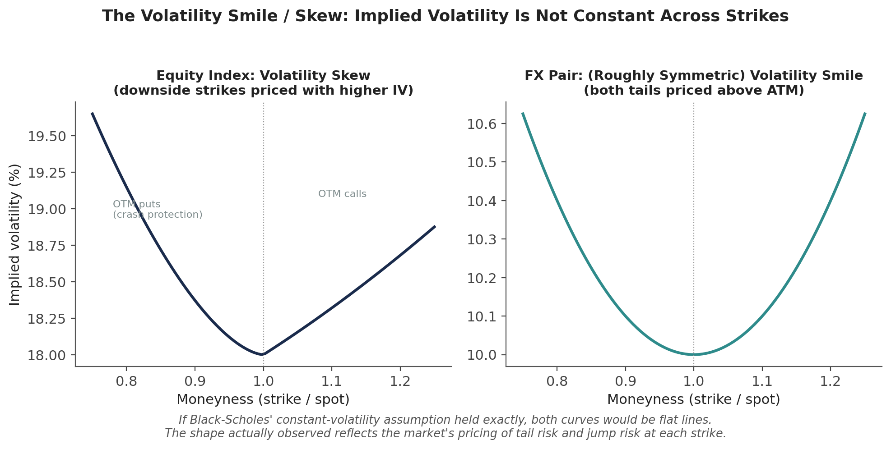
Figure 3.1 — Equity index options (left) typically show a pronounced skew: out-of-the-money puts are priced with meaningfully higher implied volatility than out-of-the-money calls, reflecting persistent demand for crash protection. FX options (right) more often show a roughly symmetric smile, since large moves in either direction are of comparable concern.
The smile/skew reflects the market pricing in a return distribution with fatter tails and (for equities) more downside risk than Black-Scholes' lognormal assumption allows for — options away from at-the-money are, in effect, priced using a higher volatility to compensate for the extra tail risk that the flat, constant-volatility model does not otherwise account for.

3.3 The Volatility Term Structure
Implied volatility also varies by maturity, holding moneyness roughly fixed: the volatility term structure. In calm markets, this typically slopes upward (contango) — near-dated realised volatility is currently low, so short-dated options price in low volatility, while longer-dated options embed a return toward more typical, higher long-run volatility levels. During market stress, the term structure often inverts (backwardation): short-dated options price in the currently elevated volatility, while longer-dated options anticipate an eventual return to calmer conditions.

3.4 The Volatility Surface as a Whole
Combining the smile/skew (varying by strike) with the term structure (varying by maturity) produces the full implied volatility surface — the complete two-dimensional object that options desks actually quote, trade, and risk-manage against, rather than any single volatility number:
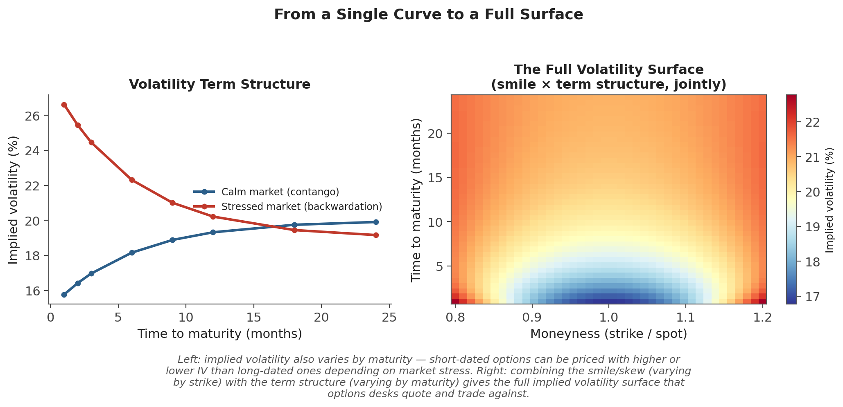
Figure 3.2 — Left: the term structure alone, in calm (contango) and stressed (backwardation) regimes. Right: the full surface — a smile shape at every maturity, and a term-structure slope at every strike, combined into one continuously varying implied-volatility grid.
Why only awareness level here — Constructing, interpolating, and no-arbitrage-checking a full volatility surface — and the local and stochastic volatility models built to explain its shape — is a substantial topic in its own right, covered in full at Level 5 (see Advanced Extensions below). The goal at this level is recognising that implied volatility is not a single number, understanding roughly why the smile, skew, and term structure look the way they do, and knowing this is the language options desks operate in day to day.

Practical Exercise
Using a single asset's daily return series covering at least two to three years (to capture more than one volatility regime):
- Compute a simple 20-day rolling standard deviation of returns, annualised, following Section 1.2.
- Fit a GARCH(1,1) model to the same return series, following Section 2.2, and extract its in-sample conditional volatility path.
- Plot both volatility estimates on the same chart and compare their behaviour, especially around the largest return shocks in the sample — which reacts faster, and which is smoother?
- Hold out the last 40–60 days as an out-of-sample test period. Re-fit GARCH on the data before that period, generate a rolling 1-step-ahead forecast across the held-out period, and compare it against the realised 20-day rolling volatility over the same period.
- Extract the fitted α and β parameters and compute α + β — how persistent is volatility in this series, and roughly how many days would a shock take to decay halfway back to its long-run level?
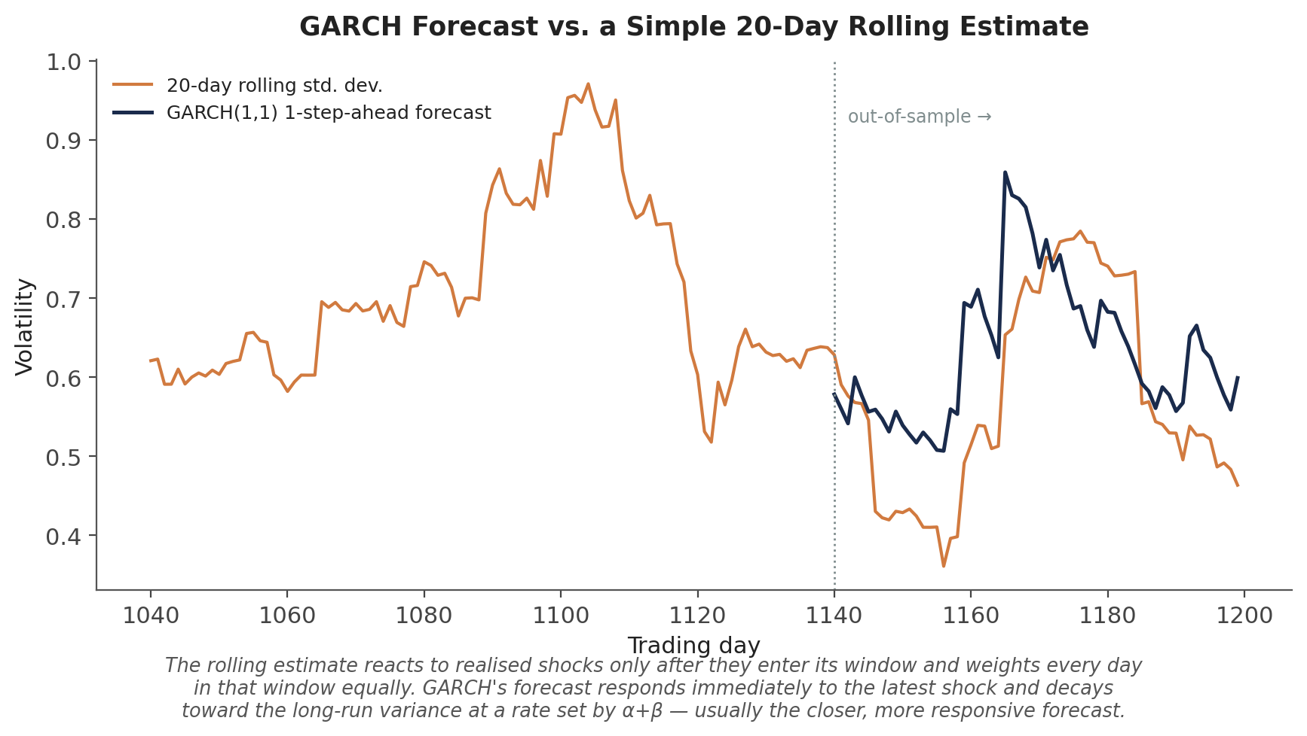
Figure — Illustrative output for this exercise: a GARCH(1,1) 1-step-ahead forecast (dark) tracks a volatility spike more responsively than a 20-day rolling estimate (orange), which only catches up once enough high-volatility days have entered its window.
from arch import arch_model
import numpy as np

rolling_vol = returns.rolling(20).std() * np.sqrt(252)

am = arch_model(returns * 100, vol='GARCH', p=1, q=1, dist='t')
res = am.fit(disp='off')
garch_vol = res.conditional_volatility / 100 * np.sqrt(252)

alpha, beta = res.params['alpha[1]'], res.params['beta[1]']
half_life = np.log(0.5) / np.log(alpha + beta) # days for a shock to decay by half

Common Beginner Mistakes
Common mistake — Using a single unconditional (constant) volatility estimate for risk management despite well-documented volatility clustering. A risk model built on one static number will be systematically wrong exactly when correctness matters most — heading into a turbulent regime — since it has no mechanism for adapting to changing conditions the way a rolling, EWMA, or GARCH estimate does.
Common mistake — Confusing historical (realised) volatility with implied (forward-looking, market-priced) volatility. These measure different things from different data sources and routinely diverge — using one where the other is called for (e.g. sizing an options trade using only historical volatility, ignoring what the market is currently pricing) is a common and costly conflation.

Advanced Extensions
Full volatility-surface modelling — constructing an arbitrage-free surface from sparse, noisy option quotes, and interpolating and extrapolating it sensibly across strike and maturity — is a substantial applied topic covered at Level 5. Local volatility models (Dupire) treat volatility as a deterministic function of the current asset price and time, calibrated to exactly reproduce the observed market surface; stochastic volatility models (Heston and its extensions) instead treat volatility itself as a second random process correlated with the underlying asset's returns, which more naturally reproduces the persistent, randomly evolving shape of the smile and term structure observed in practice. Both extend far beyond the GARCH framework covered here, which is fundamentally a discrete-time, backward-looking model, while local and stochastic volatility are typically formulated in continuous time specifically for pricing and hedging forward-looking derivative contracts.

Professional Applications
- Volatility targeting / position sizing — scaling a strategy's position size inversely to a forecast of volatility (rolling, EWMA, or GARCH-based) so that the strategy runs at roughly constant risk through both calm and turbulent regimes, rather than constant capital.
- Options pricing inputs — every option pricing model requires a volatility input, whether historical (for a first estimate), GARCH-based (for a term-structure-aware forecast), or implied (for market-consistent pricing and hedging).
- Risk limits — Value-at-Risk and Expected Shortfall calculations, and the position or notional limits built on top of them, depend directly on a volatility estimate, and a risk system that ignores volatility clustering will systematically misstate risk exactly when it matters most.

Where to Go Next
This module gives you the core vocabulary and toolkit — rolling and EWMA estimators, the GARCH family, and an awareness-level introduction to implied volatility and the volatility surface — that underpins risk management, position sizing, and derivatives work throughout the rest of the curriculum.

Suggested paths depending on your focus
- Heading into research: build a volatility-targeting overlay for an existing signal, scaling position size using a GARCH or EWMA forecast, and compare its realised risk profile against an unscaled version of the same signal.
- Heading into development: implement rolling, EWMA, and GARCH volatility as shared, well-tested utility functions, since nearly every research and production system in the curriculum will call on at least one of them repeatedly.
- Heading into trading: start reading options data in volatility terms rather than price terms — track how the implied volatility smile and term structure for an instrument you follow move around earnings, macro releases, or market stress.

